# 02/07/2019 - Capstone Meeting Notes

**Discussions:**

* Discussing sim with Tretheway
* Simple solve of the ODE in MATLAB

**Progress:**

* Parker
  + Talked to Peter McCloud, local aerospace engineer who used to work for NASA and designed re-entry modules, along with LEO spacecraft. Gist of what he said:
    - Possible use of a radiator
    - Really need to examine the Beta angle
    - What are our orbital periods
  + The sim ran determined uniform temperature across the thickness of a wall, so 1D
    - 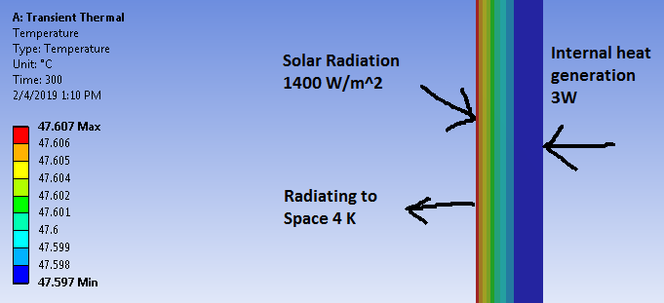
 $dT/dt =Q_{solar}/m*{c_{p}}_{} + Q_{earth}/m*c_{p} +Q_{internal}/m*c_{p }-(σ/ρx{c_{p}}_{})({T^{4}}_{OreSat} - {T^{4}}_{deep-space})$

   - m = mass of satellite (2.3kg)
    - Cp of 6061-T6 aluminum
    - $σ$ = steffan(?)-boltzmann 5.67*10^-8
    - $ρ$ density of 6061-T6 aluminum
    - x = thickness
    - F = 1
    - $ε$ = 1
    - Qearth_emission = 340 W/m^2 -> Ensure that you convert this to appropriate watt value for heat gen from earth
    - Confirms uniform temperature distribution
    - Need to double check with hand calcs
* Katherine
  + Finished edx module 4 midway through 5
* Tom
  + No new updates.
  + I need to review where we are at with someone after our meeting to catch up from last meeting.
* Jeremy
  + Midway through add module 4
  + Made slides and presented on ANSYS sum and hand calcs
* Griffin
  + Did not get nearly as much done as I had hoped. This week was busy
  + Worked a little on edX.
  + What should be the next thing we work on? More Hand Calcs? 2D? More simulation?
* Tyler
  + Worked a bit on module 4 but still did not finish it - had to pull overtime hours at work so I was pretty slammed this last week
  + Next week plan to have module 4 finished and think we should meet up to continue on with the hand calcs if anyone is down?

**Action Items:**

* Calculate the actual view factors for the satellite looking at earth, the satellite looking at the sun.
  + Think of transmitted, absorbed and radiated (radiosity).
* Appropriate emissivity value.
* Correct the current sim to include heat flux from the earth, and the correct heat dissipation from the earth being transmitted to the satellite.

**Important notes for Ansys:**

* Fix the current sim to add earth stuff
* <https://science.nasa.gov/ems/13_radiationbudget>

**Important dates:**